
HUMAN BIOLOGY UNIT 4
TASK 9 – Gene Pools and Mutations Extended Response

NAME:____________________________________________ WEIGHTING: 7.5 %
DATE: ____________________________________________ MARK: ________ %
Time allowed for the task:
- 1 week to research the topic and complete your notes at home
- 1-hour lesson to answer questions related to your research in class

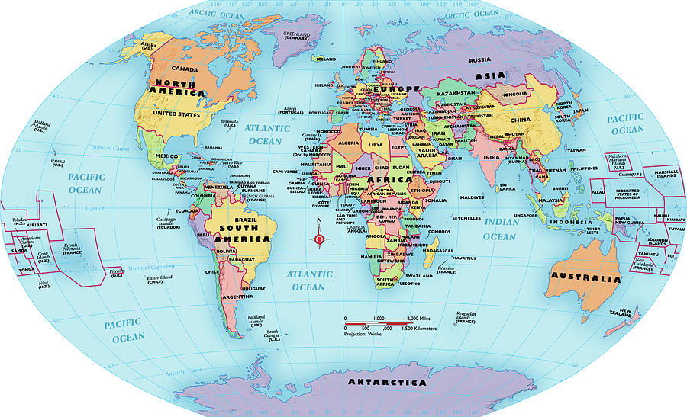
Gene pools and Mutations
The incidence of genetic diseases in particular populations illustrates the effects of different factors on the dynamics of gene pools, including the incidence of conditions like Tay-Sachs disease, thalassemia and sickle-anaemia. When conditions like these remain in a population usually there are selective agents affecting the gene pool causing natural selection to occur, or evolutionary mechanisms have created or affected the original population.

Task
Research how the following genetic conditions have been affected by evolutionary mechanisms.
- Achromatopsia in the pacific island population of Pingelap
- Huntingtons Disease in the population of Lake Maracaibo in Venezuela
- Tay-sachs in Ashkenazi Jewish populations
- Thalassemia in the Tharu people of Terai, Nepal

Part A. Research notes on each condition that includes the following:
- What is the disease, how is it inherited and how does it affect the body?
- How did the disease become more prevalent in the population stated – include which evolutionary mechanism was at work and if the condition provided a survival advantage to the population.
- Why the disease is still prevalent in the stated population today or why it has reduced.
- Is the frequency of the alleles for the disease what would be expected? Explain your answer.
These will be handed in prior to the assessment and will be marked on organisation, understanding of the concepts covered and coverage of the topic.

Part B. In-class assessment
- Specific questions based on the research notes you have made.
Requirements for assessment | Due dates
- Research notes | Thursday 1st August
- In-class assessment | Thursday 1st August

ATAR HUMAN BIOLOGY Unit 4
Task 9: Gene Pools and Mutations

Task Type: Extended Response Weighting of Task: 7.5%

Name:__________________________________________________________

- There are FOUR QUESTIONS in this extended response. You must attempt ALL of the questions.
- You are not permitted to use your notes.
- The time allowed to complete the questions is 50 minutes.

 | Marks Allocation | Your Total
Notes | 2
Question 1 | 10
Question 2 | 8
Question 3 | 6
Question 4 | 5
TOTAL | 31
 |  | Percentage %

Complete the following questions based on your research of genetic conditions affected by evolutionary mechanisms.

- Thalassemia is a commonly occurring condition amongst the Tharu people of Terai, as well as the people of the Mediterranean and parts of Asia.

- Thalassemia is a condition that affects the indigenous people of Tharu. Explain how the disease is inherited and what effects it has on the individual person. (2 marks)
__________________________________________________________________________________________
__________________________________________________________________________________________
__________________________________________________________________________________________
__________________________________________________________________________________________
__________________________________________________________________________________________

- The incident of Thalassemia is much higher in the Tharu people of Terai than the Nepalese people that have migrated into the area. Discuss the evolutionary mechanisms that have allowed these differences to occur? (5 marks)
__________________________________________________________________________________________
__________________________________________________________________________________________
__________________________________________________________________________________________
__________________________________________________________________________________________
____________________________________________________________________________________________________________________________________________________________________________________
__________________________________________________________________________________________
__________________________________________________________________________________________
__________________________________________________________________________________________
____________________________________________________________________________________________________________________________________________________________________________________

- If a long term malaria outbreak was to occur in the Terai region, what affect would you expect it to have on the allele frequencies of the gene pools in that area? (3 marks)

__________________________________________________________________________________________
__________________________________________________________________________________________
__________________________________________________________________________________________
__________________________________________________________________________________________
____________________________________________________________________________________________________________________________________________________________________________________
____________________________________________________________________________________________________________________________________________________________________________________

- During the Second World War the ancestors of the Ashkenazi Jews were exposed to a serious epidemic of Tuberculosis when living in the Ghettos. When the war was over many of the survivors fled Germany to take up residency in the USA forming a community of Ashkenazi Jews.

- Discuss how the link between the Tay Sachs allele and Tuberculosis led to a change in the allele frequency of the Jewish population living in the Ghettos. (4 marks)
__________________________________________________________________________________________
__________________________________________________________________________________________
__________________________________________________________________________________________
__________________________________________________________________________________________
____________________________________________________________________________________________________________________________________________________________________________________
__________________________________________________________________________________________
__________________________________________________________________________________________
__________________________________________________________________________________________
____________________________________________________________________________________________________________________________________________________________________________________
__________________________________________________________________________________________
__________________________________________________________________________________________

- Explain, with reference to evolutionary mechanisms, why the incidence of Tay Sachs is unusually high in the present day Ashkenazi Jewish community. (4 marks)

__________________________________________________________________________________________
__________________________________________________________________________________________
__________________________________________________________________________________________
__________________________________________________________________________________________
____________________________________________________________________________________________________________________________________________________________________________________
__________________________________________________________________________________________
__________________________________________________________________________________________
__________________________________________________________________________________________
____________________________________________________________________________________________________________________________________________________________________________________
__________________________________________________________________________________________
__________________________________________________________________________________________

- Achromatopsia is a condition that makes a person totally colour blind, causing them considerable difficulties in their everyday lives. The incidence of the condition is very rare except on the tiny remote island of Pingelap where a population has caused approximately 1 in 10 people to suffer the effects of the condition.

- Discuss the evolutionary mechanisms that have brought about the increased incidence of the disease on the island. (4 marks)

__________________________________________________________________________________________
__________________________________________________________________________________________
__________________________________________________________________________________________
__________________________________________________________________________________________
____________________________________________________________________________________________________________________________________________________________________________________
__________________________________________________________________________________________
__________________________________________________________________________________________
__________________________________________________________________________________________
____________________________________________________________________________________________________________________________________________________________________________________
__________________________________________________________________________________________
__________________________________________________________________________________________

- If the island population started to become more dependent on agriculture rather than fishing, what effect would this have on the allele frequency for achromatopsia in the island gene pool? (2 marks)

__________________________________________________________________________________________
__________________________________________________________________________________________
__________________________________________________________________________________________
__________________________________________________________________________________________
____________________________________________________________________________________________________________________________________________________________________________________
__________________________________________________________________________________________

- Huntington’s Disease is a lethal disease. People with the condition will die, but despite this the occurrence of the condition in the community of Lake Maracaibo in Venezuela is very high, so much so the government are being put under pressure to provide facilities for these people to be treated.

Discuss the evolutionary mechanisms that brought about the high incidence of Huntington’s disease in the community of Lake Maracaibo. Include an explanation that although the occurrence of Huntington’s disease is much higher on the island than elsewhere, the occurrence of the disease is not totally unexpected in a community. (5 marks)

__________________________________________________________________________________________
__________________________________________________________________________________________
__________________________________________________________________________________________
__________________________________________________________________________________________
__________________________________________________________________________________________
__________________________________________________________________________________________
__________________________________________________________________________________________
__________________________________________________________________________________________
__________________________________________________________________________________________
__________________________________________________________________________________________
__________________________________________________________________________________________
__________________________________________________________________________________________
__________________________________________________________________________________________
__________________________________________________________________________________________
__________________________________________________________________________________________

